

American International University - Bangladesh (AIUB)

**ER Diagram & Table Schema**

**Faculty: Tonny Kar Section: I**

**Project Title: The Media Library**

Group Members**:**

|  |  |
| --- | --- |
| Name | ID |
| 1. Ainea Esrat Esika | 22-46837-1 |
| 2. Swajan Barua | 22-46838-1 |
| 3. A. F. M. Rafiul Hassan | 22-47048-1 |

**ER DIAGRAM**

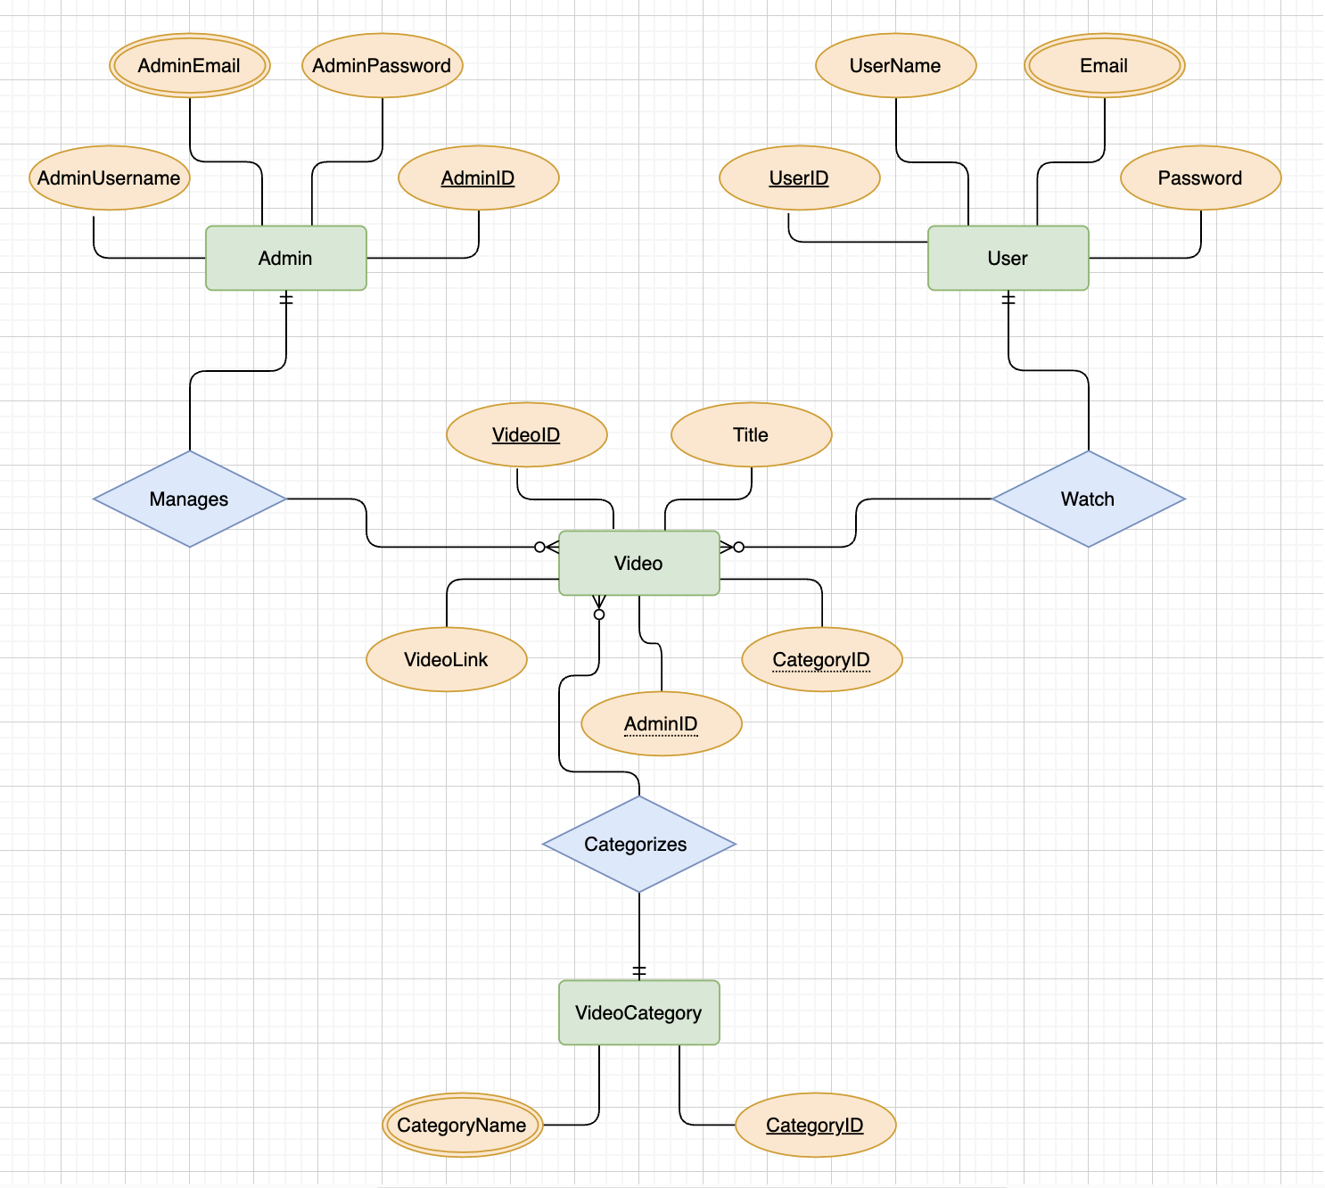

**Table Schema**

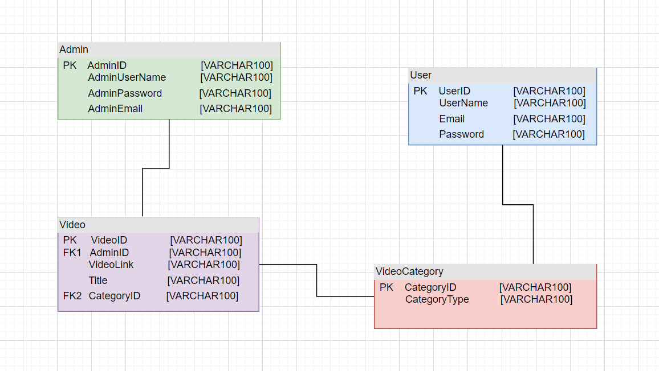

**The Media Library**

USE CASE:

The use case centers around the User Registration and Video Watching features of a locally hosted C# application, aiming to emulate a Netflix-like experience. The primary actor in this narrative is the User, with the admin serving as a supporting actor responsible for video uploads. The scenario unfolds within the context of a functional system, ensuring the user's access to the application, and begins with the precondition that the user is not logged in.

The User Registration process commences as the user launches the application and chooses to register. The system, in response, presents a registration form soliciting vital details: username, email, password, and preferred video categories like horror, romantic, funny, and action. Post form submission, the system meticulously validates the provided information. Upon successful validation, a new user account is instantiated, and the relevant details are securely stored in the database. The user is then sent a confirmation message, culminating in the finalization of the registration process.

After registration, the user proceeds to log in. Entering credentials in a designated login form, the system diligently verifies these against the stored user data in the database. Successful authentication leads to the user gaining access to the application's features and being directed to a personalized home screen.

Within this personalized space, the user encounters various video categories. These encompass genres such as horror, romantic, funny, and action, allowing users to explore diverse content options. Further exploration within a chosen category unveils a list of available videos. The user can effortlessly scroll through this list to find a specific video of interest.

Engaging in the act of watching a video involves the user selecting their desired content. The system, in response, retrieves the associated video link from the database and presents it through an integrated video player interface. This facilitates a seamless and enjoyable viewing experience for the user.

The alternative flows cater to instances where the user provides invalid registration information, prompting a correction, or when incorrect login credentials are entered, necessitating a retry. Additionally, if a user attempts to watch a video without being logged in, the system prompts them to log in first.

In postconditions, successful user registration and login grant access to personalized content recommendations. Exceptional flows, marked by technical issues, prompt the system to furnish clear error messages, guiding the user through a systematic retry process.

**Here's a normalization process for the entities in your ER diagram:**

Initial Tables:

1. Users Table (Unnormalized):

- UserID (PK)

- Username

- Email

- Password

2. Videos Table (Unnormalized):

- VideoID (PK)

- Title

- VideoLink

- CategoryID (FK)

- AdminID (FK)

3. VideoCategories Table (Unnormalized):

- CategoryID (PK)

- CategoryName

4. Admins Table (Unnormalized):

- AdminID (PK)

- AdminUsername

- AdminEmail

- AdminPassword

First Normal Form (1NF):

Users Table:

- UserID (PK)

- Username

- Email

- Password

Videos Table:

- VideoID (PK)

- Title

- VideoLink

- CategoryID (FK)

- AdminID (FK)

VideoCategories Table:

- CategoryID (PK)

- CategoryName

Admins Table:

- AdminID (PK)

- AdminUsername

- AdminEmail

- AdminPassword

Second Normal Form (2NF):

Users Table:

- UserID (PK)

- Username

- Email

- Password

Videos Table:

- VideoID (PK)

- Title

- VideoLink

- CategoryID (FK)

VideoCategories Table:

- CategoryID (PK)

- CategoryName

Admins Table:

- AdminID (PK)

- AdminUsername

- AdminEmail

- AdminPassword

Third Normal Form (3NF):

Users Table:

- UserID (PK)

- Username

- Email

- Password

Videos Table:

- VideoID (PK)

- Title

- VideoLink

- CategoryID (FK)

VideoCategories Table:

- CategoryID (PK)

- CategoryName

Admins Table:

- AdminID (PK)

- AdminUsername

- AdminEmail

- AdminPassword

**Here are the final normalized tables based on the Third Normal Form (3NF) for the entities in the ER diagram:**

Users Table:

- UserID (Primary Key)

- Username

- Email

- Password

VideoCategories Table:

- CategoryID (Primary Key)

- CategoryName

Admins Table:

- AdminID (Primary Key)

- AdminUsername

- AdminEmail

- AdminPassword

Videos Table:

- VideoID (Primary Key)

- Title

- VideoLink

- CategoryID (Foreign Key referencing VideoCategories)

- AdminID (Foreign Key referencing Admins)